Lab 8: AWS and Azure Price Calculator
Theory:
Cloud computing platforms such as Amazon Web Services (AWS) and Microsoft Azure follow a pay-as-you-go pricing model, where users are charged based on the resources they consume. Before deploying applications in the cloud, it is important to estimate the cost of required resources to avoid unexpected expenses and to select a cost-effective cloud provider.
AWS and Azure provide online pricing calculators that help users estimate the monthly cost of cloud services by configuring parameters such as compute power, memory, storage, database services, load balancing, and networking.

Steps:
AWS Pricing Calculator:
- Open the AWS Pricing Calculator website.
Click on Add service and select Amazon EC2.
Configure the EC2 instance with the following specifications:
  - Operating System: Linux
  - Instance type: t4g.large
  - vCPU: 2
  - Memory: 8 GB
  - Region: US East (N. Virginia)
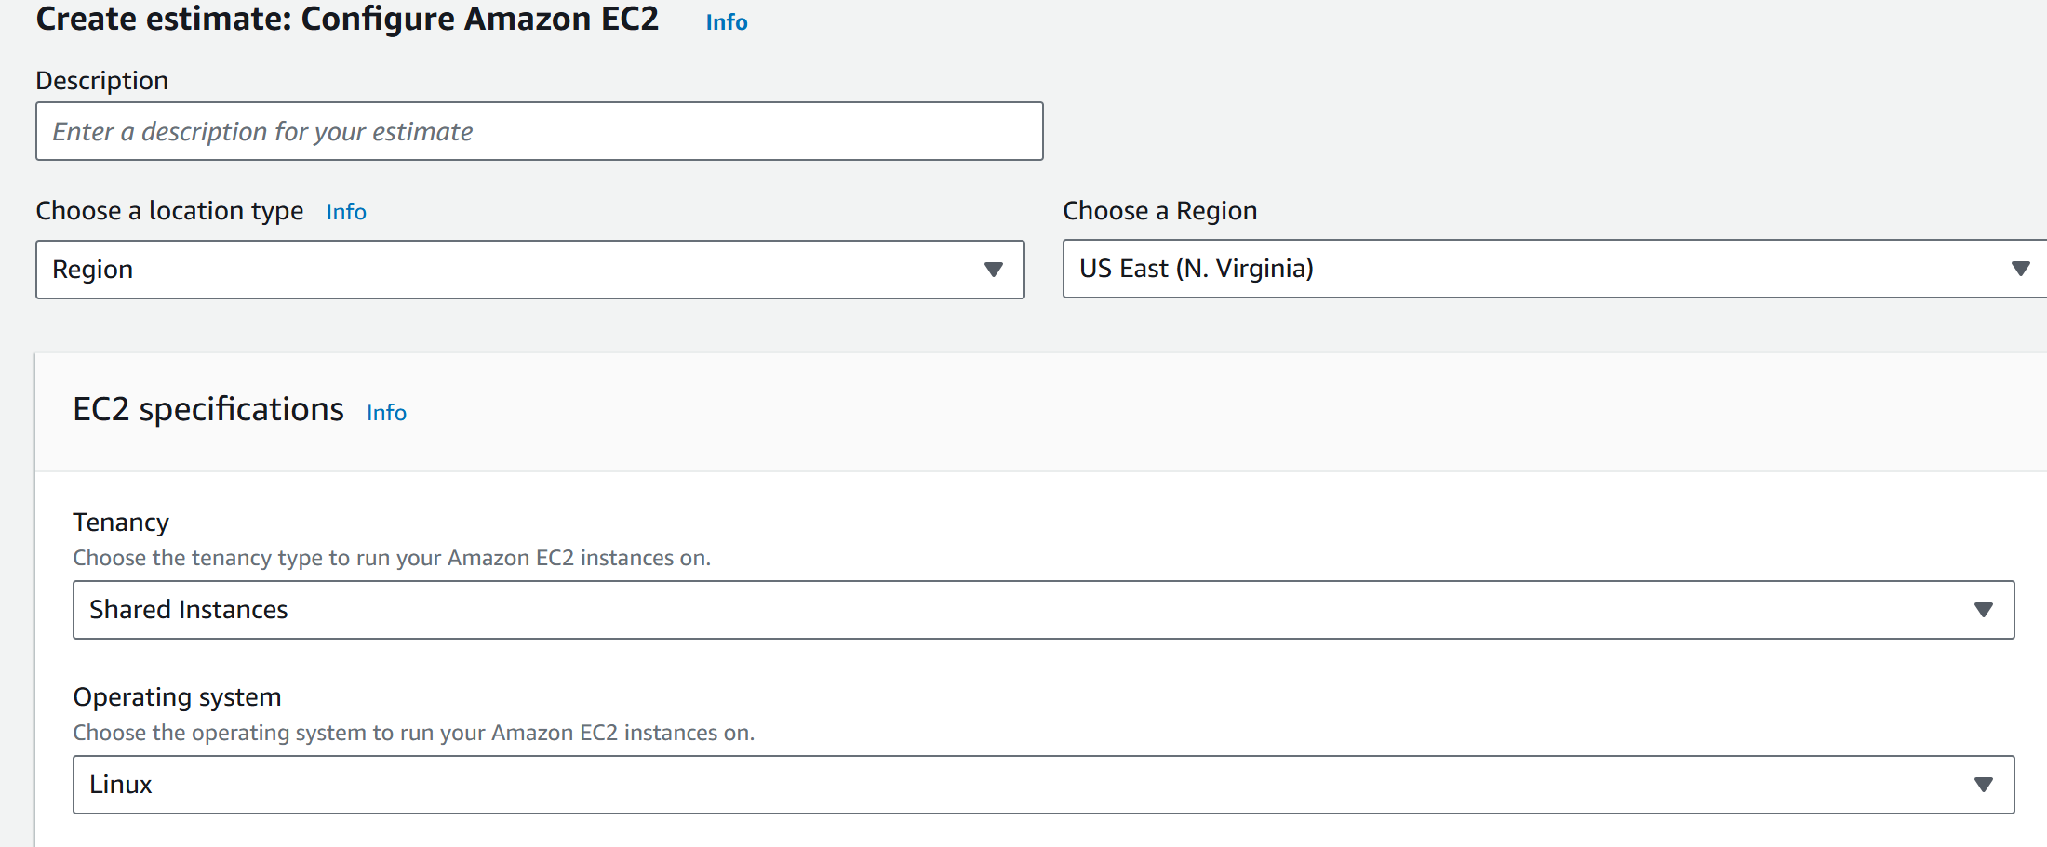
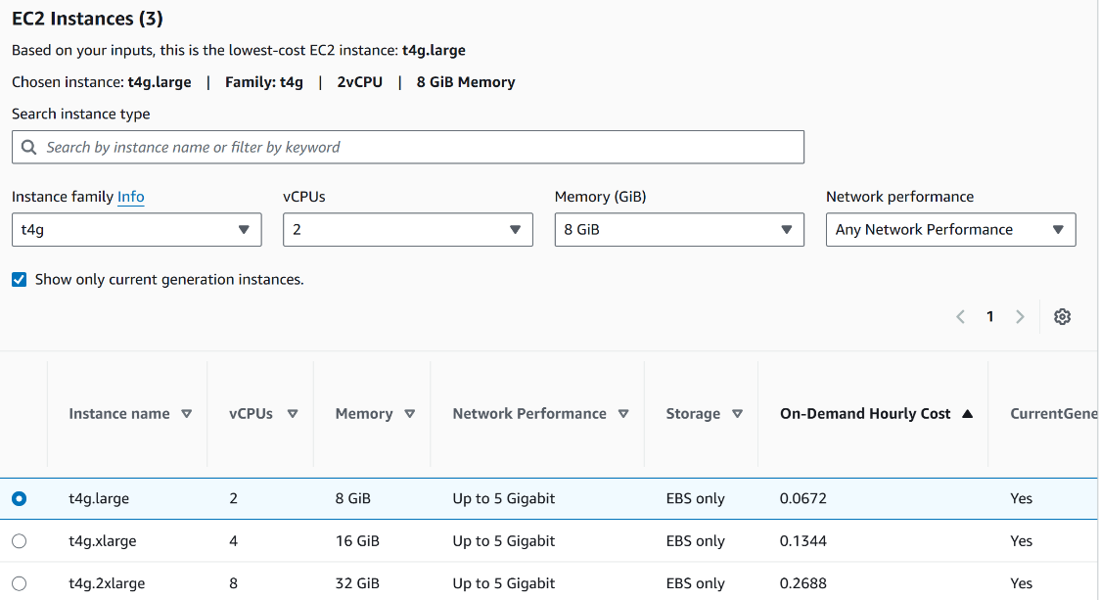
- Add Application Load Balancer (ALB) service.
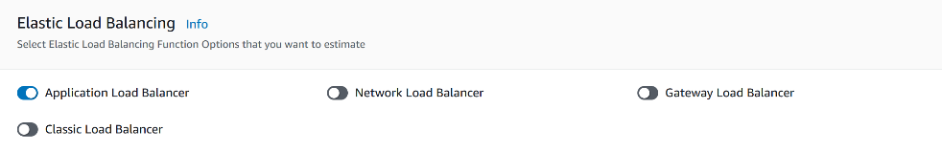

- Add Amazon RDS service.
Configure the database with the following settings:
  - Database engine: SQL Server
  - Instance class: db.m5.large
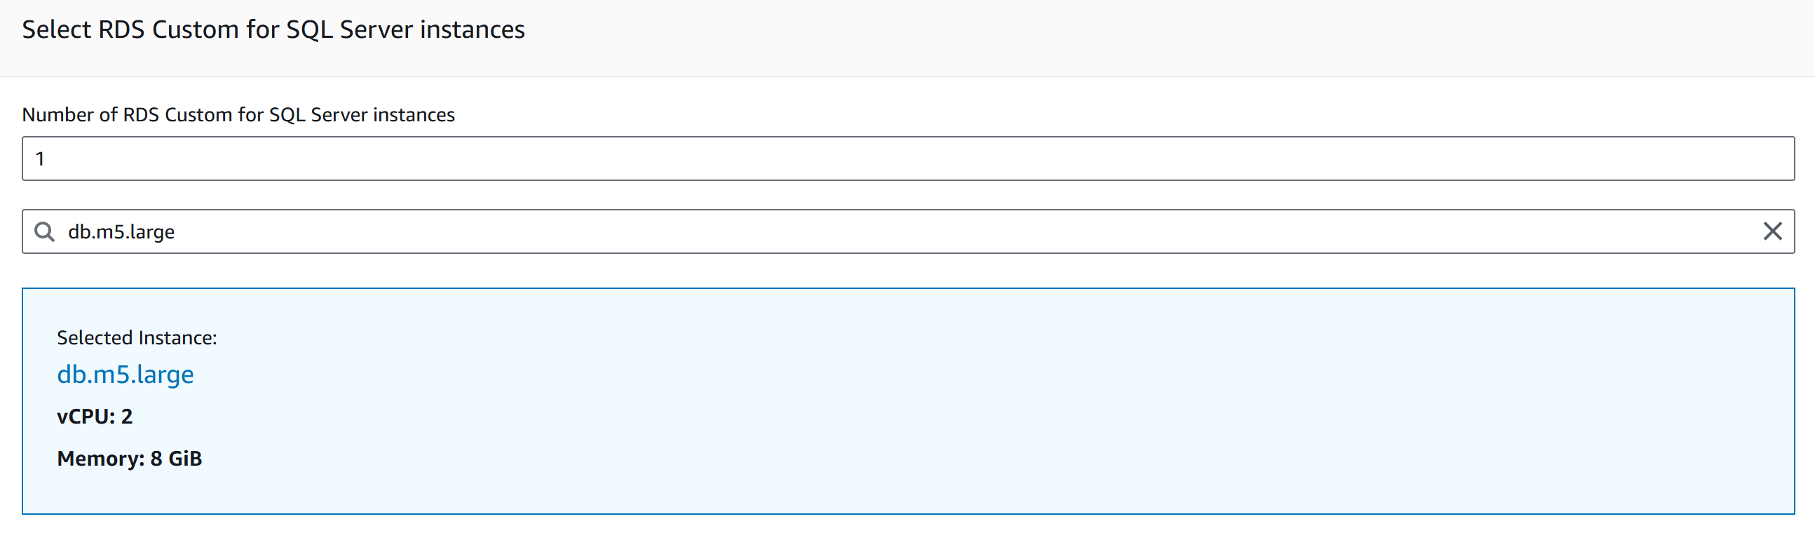

- Add 1 Static Public IP.
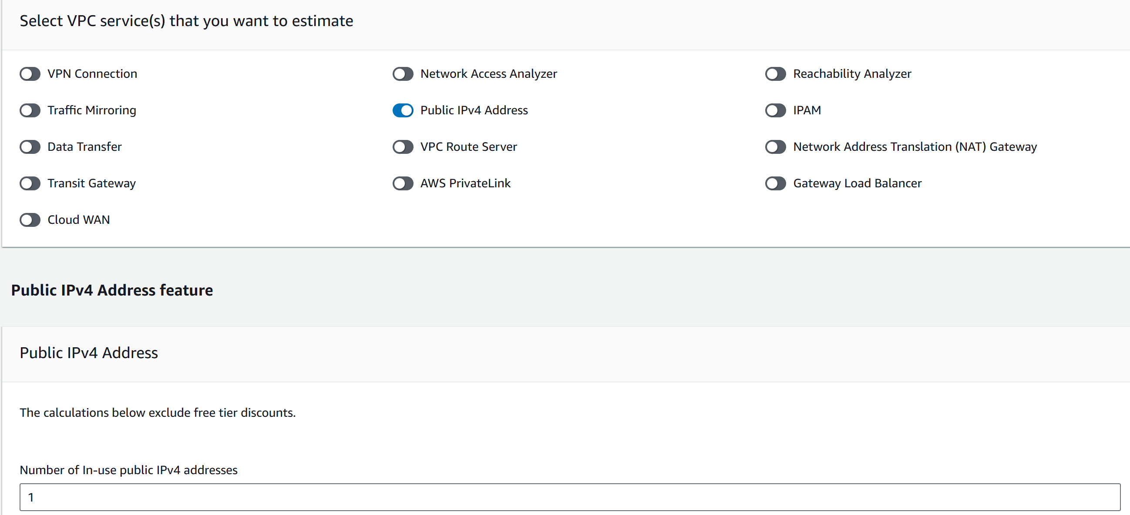
- Review the configuration and note the estimated monthly cost.
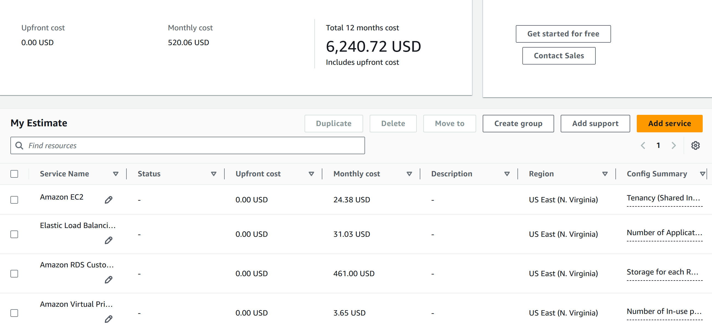

Azure Pricing Calculator:

- Open the Azure Pricing Calculator website.
Add Virtual Machine service.
Configure the VM with the following specifications:
  - Operating System: Linux
  - VM size: Standard B2ms
  - vCPU: 2
  - Memory: 8 GB
  - Region: East US
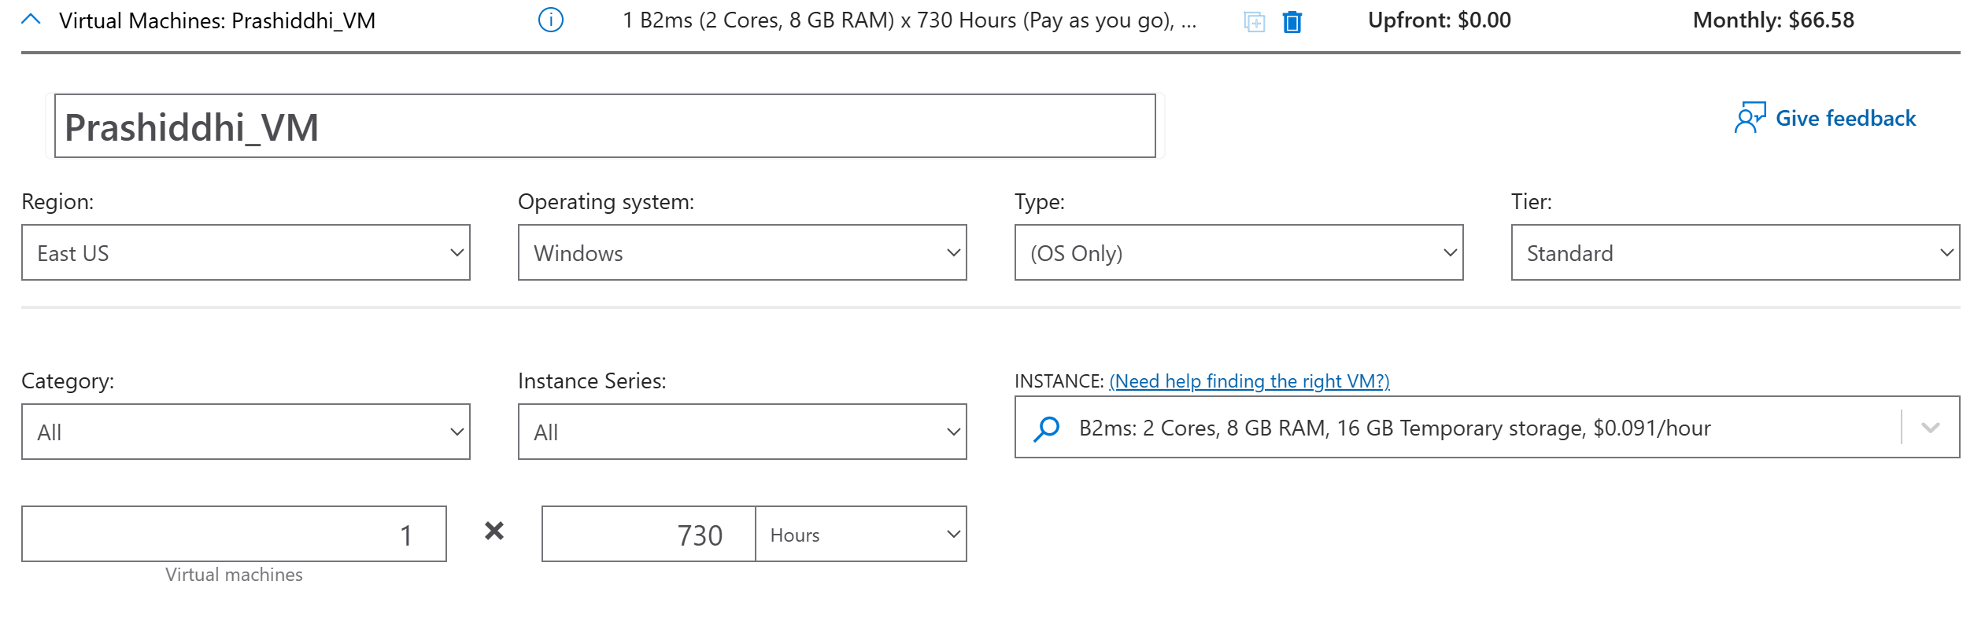
- Add SSD storage and configure:
- Storage size: 100 GB
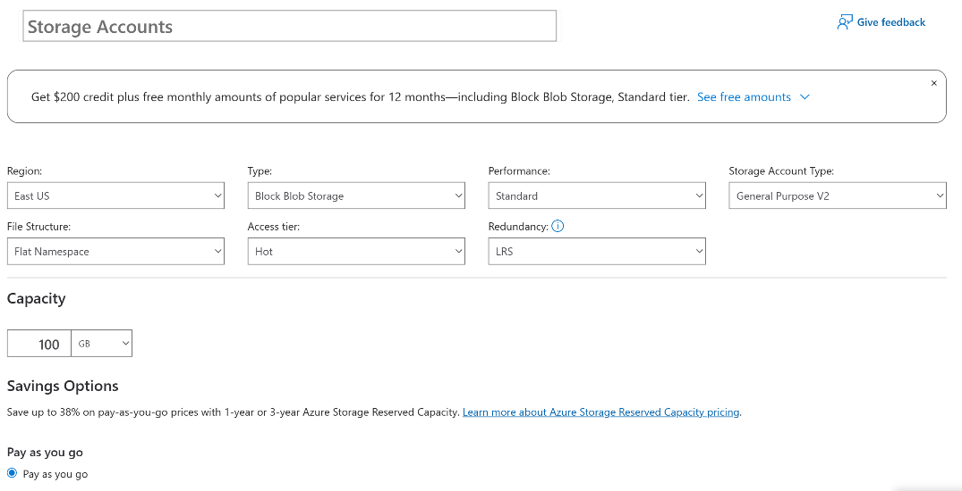

- Add Azure Standard Load Balancer.
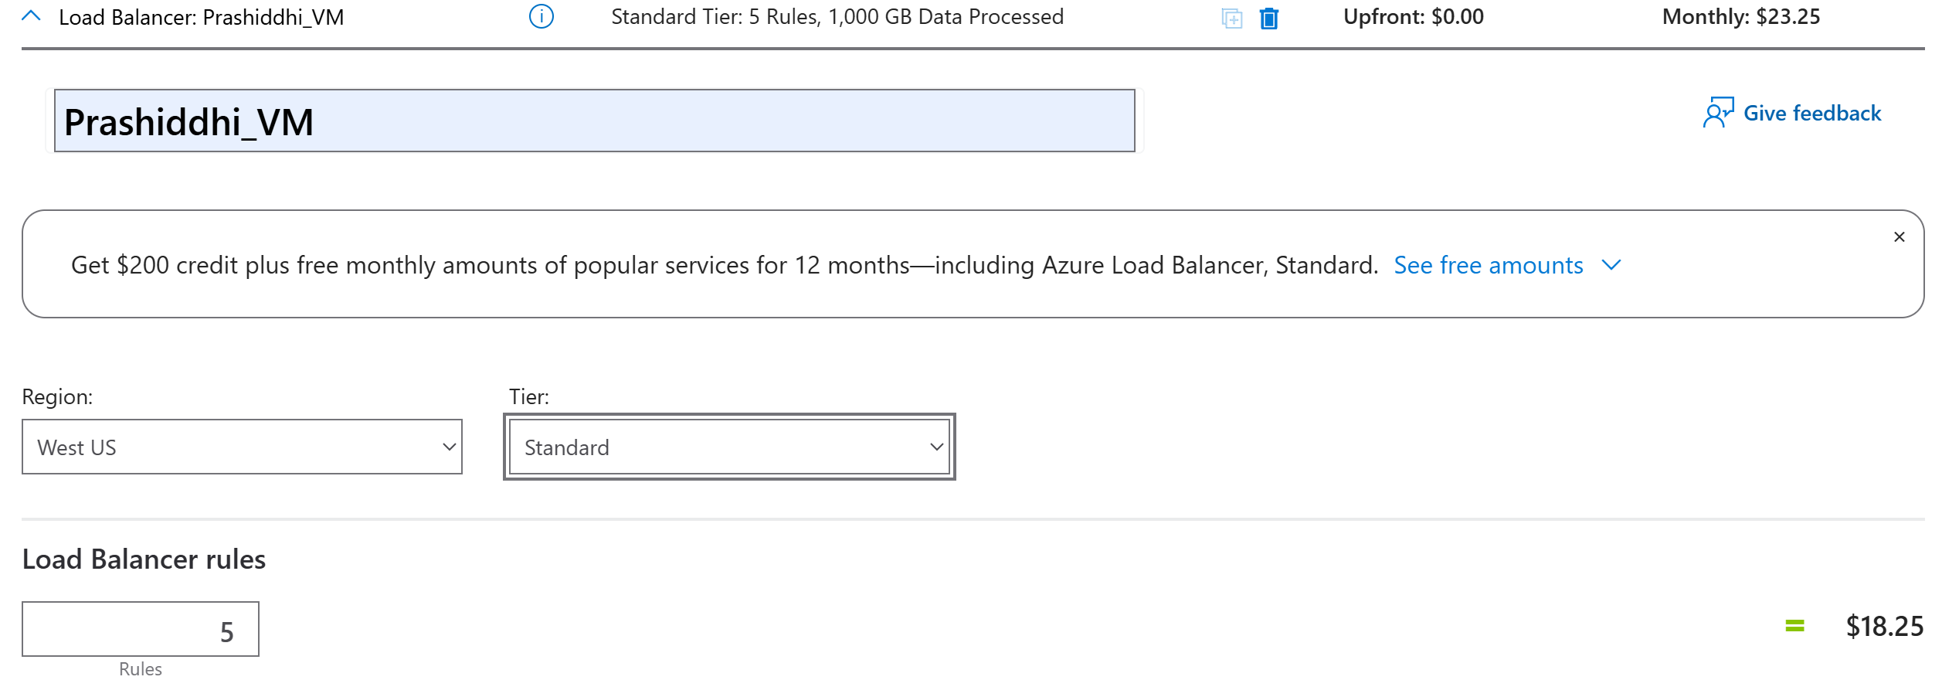

- Add Azure SQL Database service
- Configure the database with the following settings:
  - Compute tier: General Purpose
  - vCore: 2 (Gen5)
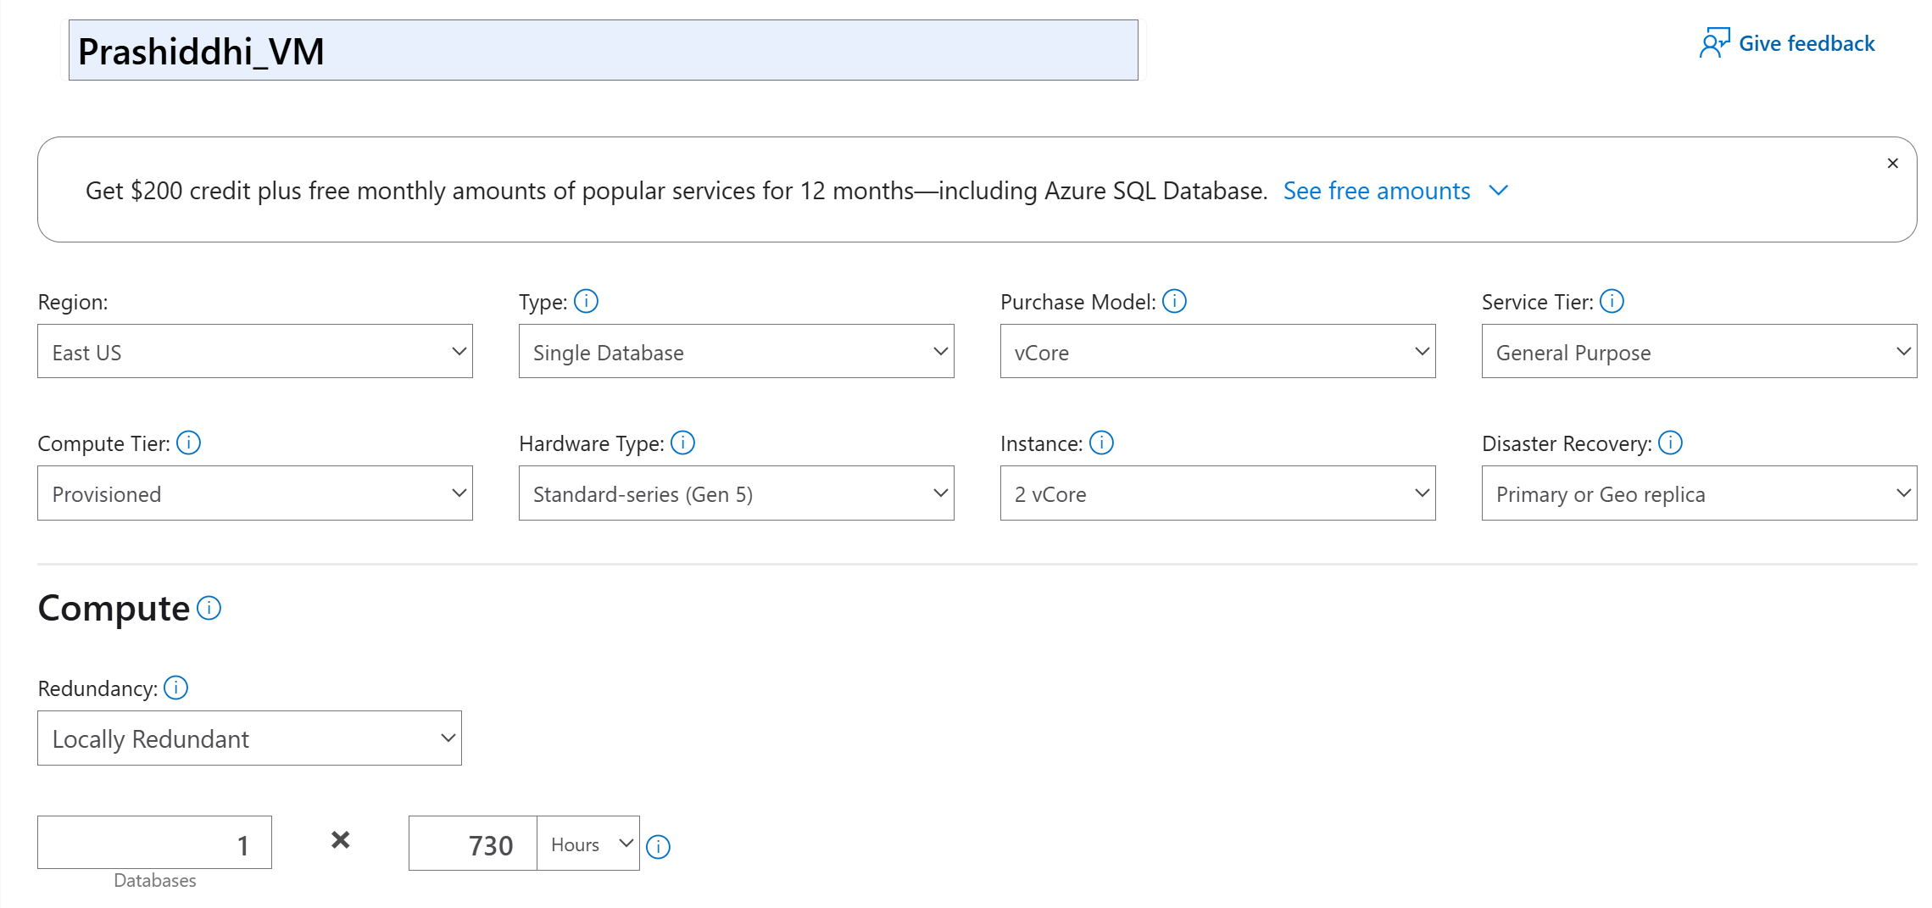
- Add 1 Static Public IP

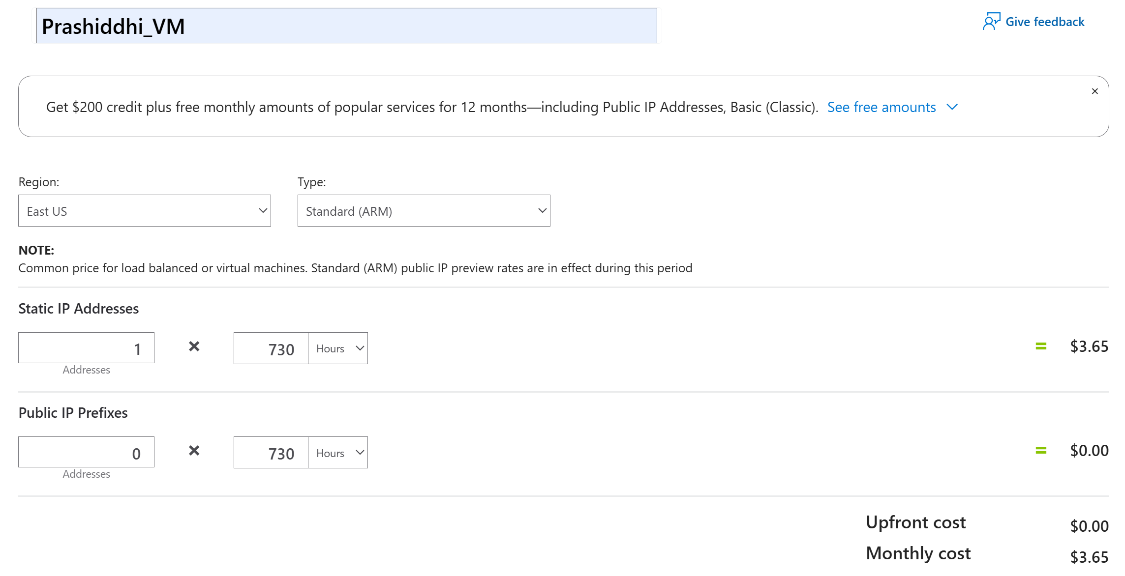
- Review the configuration and note the estimated monthly cost.
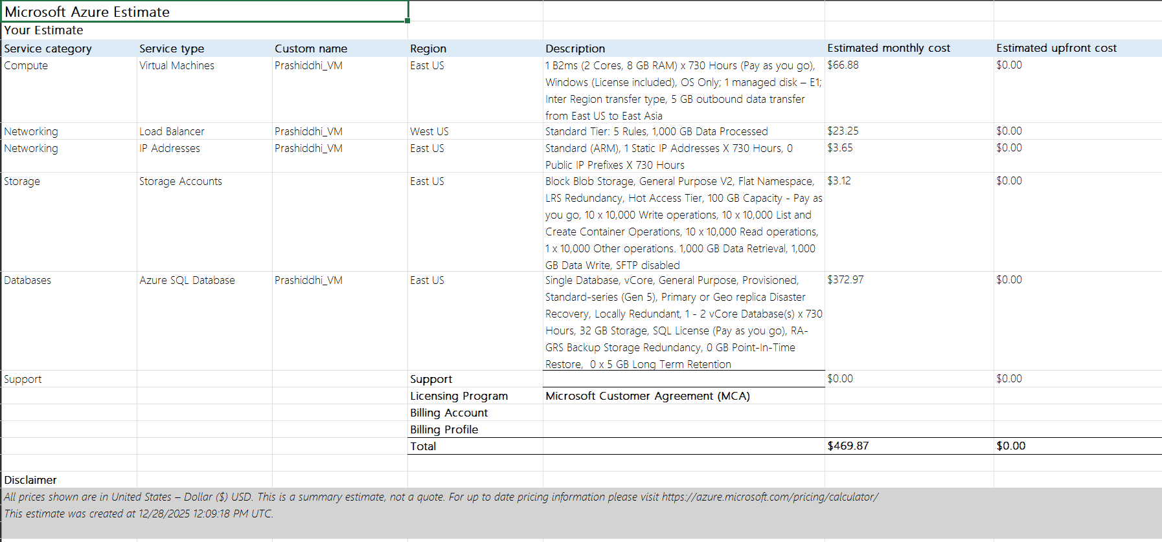

Result and Conclusion:
Result: Azure is cheaper than AWS for this scenario.
Azure total: $469.87/month AWS total: $520.06/month Difference: Azure is approximately $50.19 less per month than AWS for fully equivalent resources and region.
Biggest impact comes from:
- Managed SQL database: Azure SQL Database ($372.97/month) is less expensive than AWS RDS Custom ($461.00/month) – a difference of about $88/month
- Compute costs: Azure VM ($66.88/month) vs AWS EC2 ($24.38/month) – AWS is cheaper here by about $42, partially offsetting the database savings
- Storage, networking, and load balancer costs are relatively similar between both platforms with minor variations
Conclusion: This lab demonstrated the use of AWS and Azure pricing calculators to estimate and compare cloud infrastructure costs. By configuring equivalent resources on both platforms, a fair cost comparison was achieved. The results indicated that AWS was more cost-effective for the specified requirements. Pricing calculators are essential tools for cloud planning, helping users select appropriate services, manage budgets, and make informed decisions before deploying applications in the cloud.

